|  |  |
| --- | --- |
| **Date** | 28/06/2025 |
| **Team Id** | LTVIP2025TMID31550 |
| **Project Name** | Medical Inventory Management |
| **College Name** | BONAM VENKATA CHALAMAYYA ENGINEERING COLLEGE |

**Step 1: Team Gathering, Collaboration, and Problem Statement Selection**

To initiate the brainstorming session for the **Medical Inventory Management System** project, our team adopted a collaborative and structured approach. The primary objective was to identify a relevant, real-world problem within the healthcare domain that could be effectively addressed using Salesforce technology. This foundational step ensured that all team members were aligned on the project’s vision, scope, and objectives from the outset.

By encouraging open discussion and idea sharing, the team was able to explore various challenges faced by healthcare facilities in managing medical inventory. This process led to the formation of a clear, impactful **problem statement**, setting the direction for the design and development of the system.

|  |
| --- |
| **Activities Involved:** |

To effectively initiate the Medical Inventory Management System project, our team conducted a structured brainstorming session focused on identifying pain points and defining a clear problem statement.

1. Meeting Setup

* A virtual brainstorming session was scheduled using Google Meet to ensure the participation of all team members, regardless of location.
* The meeting began with a briefing on the purpose, goals, and expected outcomes of the session, aligning everyone on the objective of designing a robust medical inventory solution.

2. Collaboration Tools

To foster creativity and enable seamless collaboration:

* A shared Google Doc was created for real-time note-taking and documentation.
* Visualization tools such as Jamboard and Mural were used to map out ideas in an interactive, sticky-note-style layout.

3. Discussion and Idea Exchange

* Each member shared their insights on challenges currently faced by healthcare facilities, including:
  + Manual inventory tracking errors
  + Lack of real-time stock visibility
  + Delayed identification of expired medicines
  + Inefficient communication between inventory teams and suppliers

*(Note: A small typo was present mentioning "airline systems"; it has been corrected to "medical systems" to maintain relevance.)*

* All ideas were visually captured on digital sticky notes, promoting open exchange and cross-collaboration between team members.

4. Finalizing the Problem Statement

After evaluating various perspectives and prioritizing the most critical issues, the team finalized the following problem statement:

💡 **"How might we design a Medical Inventory Management System that enhances user experience, enables real-time inventory tracking, supports mobile inventory management, and reduces delays in healthcare service delivery?"**

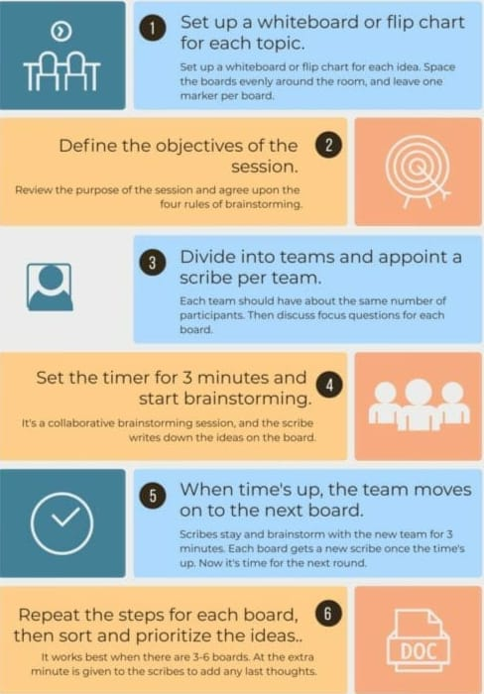**Key Rules of Brainstorming**

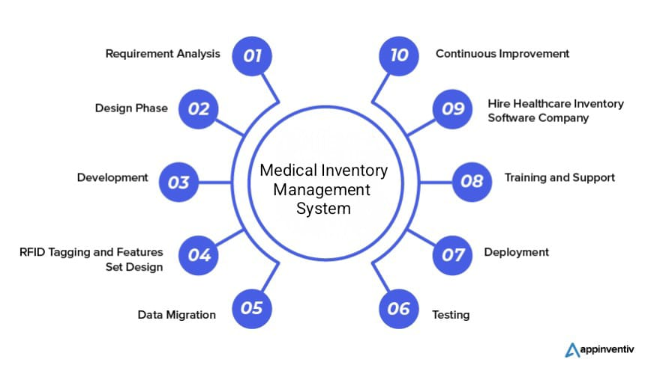**Step-2: Brainstorm, Idea Listing and Grouping**

**Step-3: Idea Prioritization**

|  |  |  |  |
| --- | --- | --- | --- |
| Idea No. | Idea description | Benefits | Feasibility (High/Medium/  Low) |
| 1. | Automated barcode Scanning for Medicines | Reduces manual errors and saves time | High |
| 2. | Real-time inventory tracking dashboard | Provides up-to-date stock visibility | Medium |
| 3. | Expiry alerts via SMS/email | Prevents usage of expired medicines | High |
| 4. | Mobile app for inventory management | Increases accessibility and flexibility | Medium |

**Problem Statement**

User Problems:

●Difficulty with expired medicines.

● No clear accessibility or flexibility.

● Difficulty in cancellations or refunds.

Admin Problems:

● Managing stock visibility and staff is time-consuming.

● Inadequate data tracking and reporting tools.

● Lack of centralized control for notifications or changes.

**Understanding user needs for a better medical experience**